Community Service Awards

This Award is a great opportunity to acknowledge and celebrate significant voluntary contributions that make City of Prospect such a great place to live, work and recreate. Available since 2009, each year there has been an average of 10 Award recipients.

The Award process is community driven, Council understands that communities themselves are best placed to know and appreciate whom in their community, Community Group or Sport Club has made a significant voluntary contribution over the past 12 months.

Each nominee will receive a Community Service Award. Individuals, Community Groups and Sport Clubs may conduct their own assessment and then submit a nomination.

Nominate a Community Group/Sport Club
Our local Community Groups and Sport Clubs make positive contributions to the wellbeing of our communities; is there a standout project, program or initiative over the previous 12 months that has made as a significant voluntary contribution?

or

Nominate an Individual
Is there an individual in your community, Community Group or Sport Club whose significant voluntary contributions over the previous 12 months can be recognised and celebrated?

Nomination Process
- Each nominee will receive a Community Service Award.
- Complete and submit the below Nomination Form.
- The nominator should not be the same individual, Group or Club as the nominee.
- Nominations should include the contact details of the nominator.
- Please return completed nominations form by email to admin@prospect.sa.gov.au or hand deliver to Payinthi, 128 Prospect Road, Prospect.
- Nominations Close: 5pm on Friday, 1 April 2022.
- Further information is available at https://www.prospect.sa.gov.au/community/programs-and-initiatives/community-service-awards.

Presentation
Presentation of Community Service Awards is a feature of Council’s volunteer recognition event held during National Volunteer Week in May of each year.

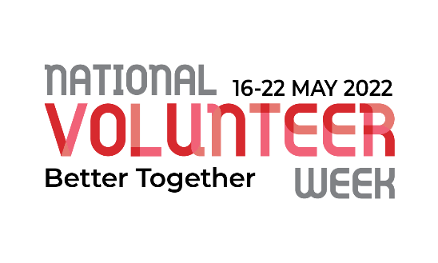
- Both the nominator and Award recipient will receive an invitation to attend the event. Community Groups and Sport Clubs will receive invitations for two representatives to attend.
- All of Council’s volunteers receive an invitation to attend the event.

NOMINATION FORM
Nominee:
- Indicate whom you are nominating to receive a Community Service Award.
- Choose one only for each Nomination Form. I.e. Individual or Community Group/Sport Club

Name of the Individual or
Community Group / Sport Club
Email:
Postal Address
Telephone:
Award Category (please check only one  ) |  | Individual |  | Community Group / Sporting Club
Reason for Nomination:
Describe how the Individual or Community Group / Sport Club has made a significant voluntary contribution to our community over the past 12 months?
.
Additional information may be attached (maximum of 2 pages)
Nominator: Your details
Name:
Email:
Postal Address:
Telephone:

