Categories:

Citizen of the Year
To be eligible, the person must be an Australian Citizen.

Young Citizen of the Year
To be eligible, the person must be at least 16 years of age, but under 30, on 26 January of the Awards year.

Community Event of the Year
This is presented to the person/group who has staged the most outstanding community event during the past year.

Award for Active Citizenship
This Award would be for a person or group delivering outstanding work for an event or cause staged in the community during the past year.

Procedure:
City of Prospect award recipients will be announced at an event that will adhere to ongoing COVID-19 restrictions, details of the event are yet to be determined. Each nominee who does not receive a 2021 Citizen of the Year Award will receive a City of Prospect Community Service Award to be presented at
our National Volunteer Week Event scheduled for May 2021.
The Citizen of the Year Awards are proudly presented by the Australia Day Council of South Australia, sponsored by On the Run, Sarah Constructions and the Local Government Association of South Australia. The Citizen of the Year Awards are administered by local Councils across SA.
The Awards reward and recognise individuals and organisations that have made a noteworthy contribution during the current year, and/or given outstanding service over a number of years, to a local community over and above normal employment duties.
Outstanding contribution and community service include areas such as education, health, fundraising, charitable and voluntary services, business, sport, arts, the environment, or any other area that contributes to the advancement and well being of a community.
Nominate someone who makes a real difference in your community and give them the opportunity to be rewarded and recognised for their important contribution.
Visit the website:

www.prospect.sa.gov.au/CitizenAward
for more information on the awards, including past winners.

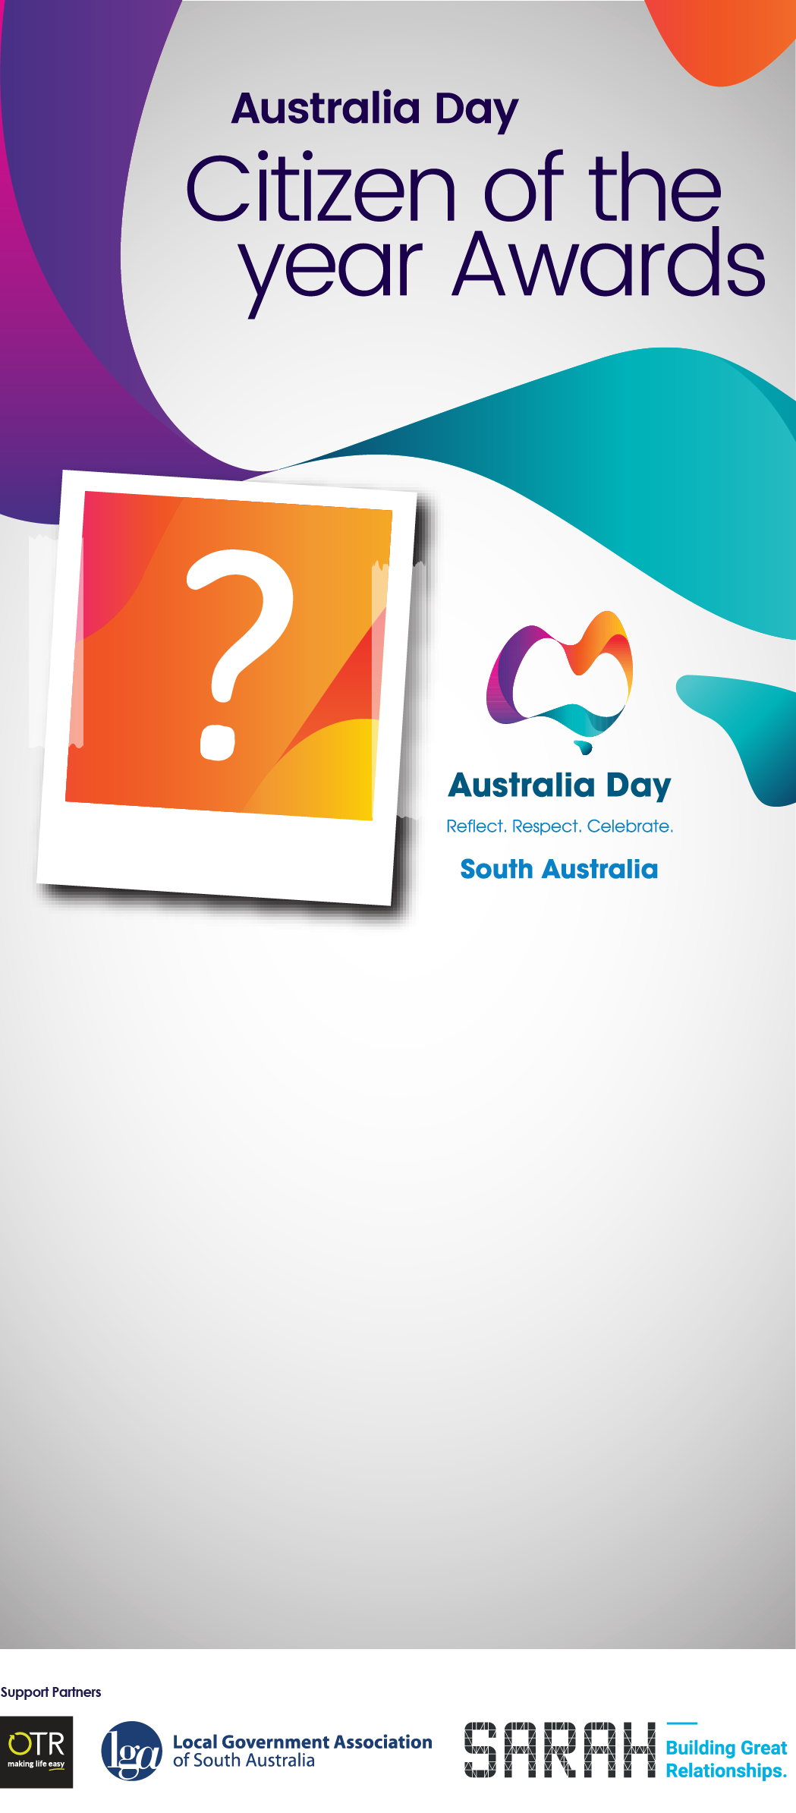

Who makes a difference
in your community?
Nominations are now open:
- Citizen of the Year
- Young Citizen of the Year
- Community Event of the Year
- Award for Active Citizenship

Awards will be presented at an event that will adhere to ongoing COVID-19 restrictions, details of the event are yet to be determined.

www.prospect.sa.gov.au/CitizenAward

Nomination Form:
Nominee (the person / organisation you would like to nominate)
Please provide as much information as possible. Additional documents may be attached providing further information of testimonials of achievement.

Award Category: (please tick)

 | CITIZEN |  | YOUNG CITIZEN |  | COMMUNITY EVENT |  | ACTIVE CITIZENSHIP

Name:
Address:
Phone: |  | Date of Birth:
Email:

Is the person being nominated an Australian citizen? |  | Yes |  | No

Reason for nomination.

How has the person / organisation contributed to the community?

Please list any other significant contributions and / or achievements:
Additional material may be attached: maximum five A4 pages, minimum font size 10 point.

Nominator (your details)
Name:
Address:
Phone: |  | Email:

I give permission for City of Prospect to submit this nomination to other recognition programs such as the Australian of the Year Awards.

Please return completed form before Friday 13th November 2020 to: City of Prospect, PO Box 171 Prospect SA 5082 or 128 Prospect Road, Prospect or email admin@prospect.sa.gov.au

