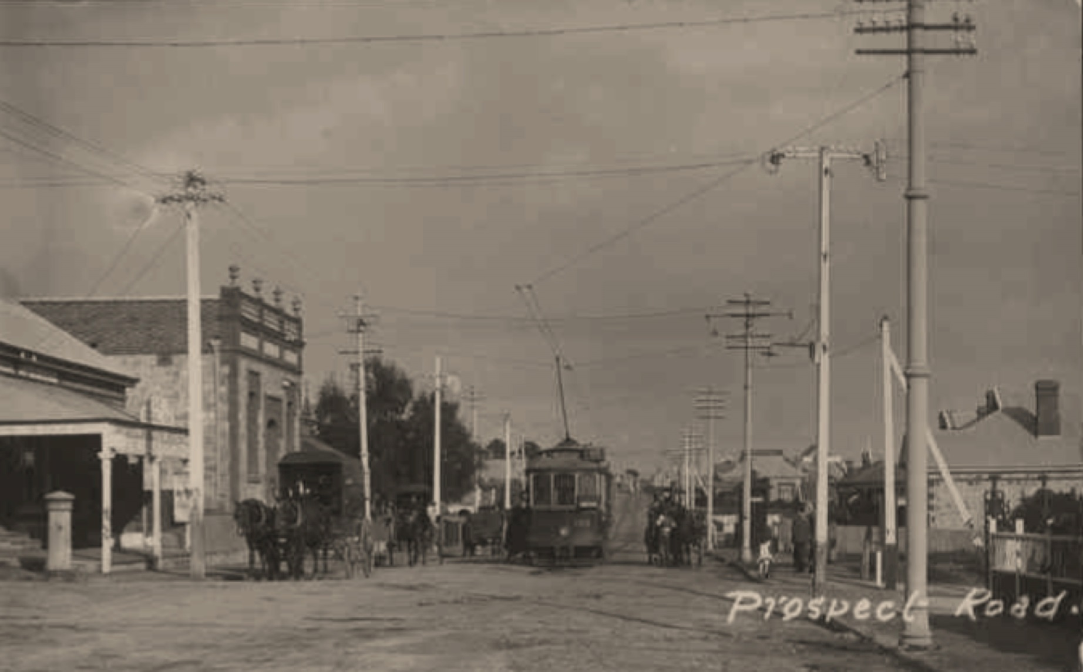

Heritage Grant Program

Guidelines and Application Form

**What is the Heritage Grant Scheme**

City of Prospect’s Heritage Grant Program assists owners of Local Heritage Places, State Heritage Places and Contributory Items within the Historic (Conservation) Zone, with the partial funding of conservation work undertaken on the property.

**What kind of work is eligible for Grant Funding?**

Grant funding is available to assist in payment for external works that involve the restoration, conservation or reinstatement of the original heritage features of local heritage places, State heritage places and contributory items within Council’s Historic (Conservation) Zone. Internal works will not be eligible for funding.

**How much Grant funding could I receive?**

The Council will refund 50% of the cost of the conservation work up to a maximum of $2,000 per property. There is no minimum value of works required to be eligible.

**Who can apply for Grant funding?**

Owners of local heritage places, State heritage places and contributory items within a Historic (Conservation) Zone in City of Prospect may apply for Heritage Grant funding.

**How do I apply for Grant funding?**

Grant funding is made by way of reimbursement following the completion of works. To ensure that your project is eligible for grant funding prior to works commencing, you should follow the process outlined below:

**Step 1:** Submit your preliminary plans or proposal description to Council for review, together with the Heritage Grant Funding Application Form.

**Step 2:** If the proposal is considered to be in keeping with the Grant funding eligibility criteria, Council will issue a certificate of 'Approval in Principle' for Grant funding.

**Step 3:** You would then apply to Council for Development Approval via development application process (if required by Approval in Principle).

**Step 4:** Once Development Approval is granted, you would submit copies of a minimum of two quotes for the works to be undertaken.

**Step 5:** Council would then advise you of the amount of grant funding that would be allocated to your project.

**Step 6:** You would then undertake the works in accordance with the approved documentation.

**Step 7:** Upon completion of work, an inspection will be undertaken either by Council staff or a suitably qualified heritage expert. You may engage your own heritage adviser to undertake the inspection.

**Step 8:** You would then present proof of payment to Council as soon as possible.

**Step 9:** Council will then reimburse the previously agreed amount.

**How are Grant applications assessed?**

Assessment of grant applications will be made by Council administration with input from a heritage adviser. In the event that demand is high, applications will be assessed on their merits and higher priority may be given to:

• Recently designated Heritage Places

• Buildings that make a prominent contribution to the streetscape

• Buildings that have not previously received Grant funding

• Projects which support the building’s significant heritage elements

• Buildings that are owned by institutions or incorporated associations and have a community use

• Buildings in multiple ownership where each owner has agreed to cooperate in undertaking conservation works

• Buildings which have not been recently unsympathetically modified

**When would I receive the Grant money?**

Reimbursement would be made at the conclusion of works being undertaken to the satisfaction of Council administration, assisted by an inspection of the works by an independent heritage adviser.

The following details may also be required by Council prior to reimbursement being issued:

• Receipts made out to the applicant with appropriate details

• Proof of payment by the applicant

• Tax Invoice (if the applicant has an ABN)

• Certificate of Practical Completion (if required)

**Limitations on Grants**

The Council will refund 50% of the cost of the conservation work up to a maximum of $2,000 per property.

Projects must be completed within the life of the Development Approval (if required) or funds will be forfeited.

**Liability**

Quality assurance is the building owner’s responsibility. Council will not warrant the workmanship or other qualities of the work as a result of an inspection or visit.

Council will accept no liability in any respect for any claim or damage of any form that may result from the work.

It shall be the building owner’s obligation to hold current and appropriate insurance cover. While Council will provide the financial assistance as agreed, the building owner will have full responsibility for all acts and failures to act by any party in relation to design, documentation, contract(s) or the work on site.

**Publicity**

Council has the right to photograph or video the building prior to work, while work is in progress and/or at completion and may use these photographs at Council’s discretion.

**Further Information**

For further information in relation to the Heritage Grant Scheme, or any associated matter please contact:

Council’s Policy Planner or the Manager Development Services and Communications:

128 Prospect Road

PROSPECT SA 5082

(08) 8269 5355

Email: admin@prospect.sa.gov.au

**Heritage Grant Program Application Form**

TO: City of Prospect,

PO Box 171 Prospect SA 5082

(email: [admin@prospect.sa.gov.au](mailto:admin@prospect.sa.gov.au))

|  |  |  |  |  |  |  |  |  |  |  |  |  |
| --- | --- | --- | --- | --- | --- | --- | --- | --- | --- | --- | --- | --- |
| Site Address: | | | | | | | Certificate of Title Reference: | | | | | |
|  | | | | | | |  | | | | | |
| Applicants Name:  (NB must be building owner) |  | | | | | | | | | | | |
| Applicant’s Address: | | | | | | | | | | | | |
|  | | | | | | | | P/Code: | | |  | |
| Telephone | Mobile: | | | Email: | | | | | | | | |
|  |  | | |  | | | | | | | | |
| Is the site a Local Heritage Place? | | |  | | Yes |  | | | No |  | | Don’t know |
| Is the site a State Heritage Place? | | |  | | Yes |  | | | No |  | | Don’t know |
| Is the site located within the Historic Conservation Zone? | | |  | | Yes |  | | | No |  | | Don’t know |
| Is the site a contributory item? | | |  | | Yes |  | | | No |  | | Don’t know |
| Description of conservation work for which funding is sought (please attach relevant plans and information): | | | | | | | | | | | | |
|  | | | | | | | | | | | | |
| Cost of Conservation work: *(NB a minimum of two quotes from suitable persons or companies are required)* | | | | | | | | | | $ | | |
| I/we acknowledge that I/we have read and understood the administrative arrangements, including the expressed terms and conditions, which apply to the City of prospect Heritage Grant Program and accept and agree to abide by those terms and conditions. | | | | | | | | | | | | |
| Signature of Building Owner(s) | |  | | | | | | Date: | |  | | |
|  | |  | | | | | |  | |  | | |
|  | |  | | | | | |  | |  | | |
|  | |  | | | | | |  | |  | | |